ASSIGNMENT#1

### SOFTWARE DESIGN AND ARCHITECTURE

**Name: Hassan Ali Mashwani Reg No: FA22-BSE-067 **

**Group members**

#### Ghazi Raza , Aalyan Mughal

* **SECTION: BSE 5B**

#### SUBMITTED TO: Mukhtiar Zamin

PROJECT:

AI MUSIC RECOMMEDATION SYSTEM

## USECASE DIAGRAM:

CODE:

PROJECT REPORT:

## RECEIVE PERSONAL RECOMMENDATION:

### INTRODUCTION

The **"Receive Personalized Recommendations**" feature is a pivotal component of an **Ai Powered Music Recommendation System.** This functionality leverages sophisticated

algorithms and data analytics to deliver music suggestions tailored to individual users. As music streaming becomes increasingly competitive, personalized recommendations enhance user engagement, satisfaction, and retention.

### OBJECTIVES

##### The primary objectives of the personalized recommendations feature include:

1. **Enhance User Experience**: Delivering relevant suggestions to improve user interaction with the platform.
2. **Increase Content Discovery**: Guiding users towards new and diverse music that aligns with their tastes.
3. **Drive Subscription and Retention**: Personalized experiences can significantly improve user retention and encourage premium subscriptions.

### METHODOLOGY

##### Data Collection

* 1. *User Behavior Data*
     + **Listening History**: Tracks the songs played, skipped, liked, and disliked by users.
     + **Engagement Metrics**: Monitors how long users listen to songs and their interaction with playlists.
  2. *User Profile Data*
     + **Demographics**: Information such as age, location, and gender may help tailor recommendations.

**Preferences**: Users can specify favorite genres, artists, and styles during the onboarding process.

* 1. *Social Data*
     + **Social Interactions**: Analyzing playlists shared among friends or social media activity to infer preferences.
     + **Collaborative Playlists**: Understanding how collaborative playlists affect user choices.

##### Recommendation Techniques

* 1. *Collaborative Filtering*
     + **User-Based Collaborative Filtering**:
       - Identifies users with similar listening patterns. If User A and User B have overlapping interests, songs liked by User B may be recommended to User A. o **Example**: If User A enjoys rock music and User B also enjoys rock and indie, songs that User B has liked from the indie genre may be suggested to User A.

#### Item-Based Collaborative Filtering:

* + - * Focuses on finding similarities between songs rather than users. If a user likes a specific song, the system suggests other songs that were frequently enjoyed by users who liked that song.
      * **Example**: If many users who liked "Song X" also liked "Song Y," the system will recommend "Song Y" to users who enjoyed "Song X."
  1. *Content-Based Filtering*
     + Analyzes attributes of songs (e.g., genre, tempo, mood) to suggest similar tracks. If a user listens to upbeat pop music, the system will recommend other songs with similar attributes.
     + **Example**: If a user frequently listens to upbeat, electronic dance tracks, the system will recommend new releases in that genre.
  2. *Hybrid Approaches*
     + Combines collaborative and content-based filtering to enhance recommendation accuracy. This approach can mitigate limitations, such as the "cold start" problem (difficulty in making

recommendations for new users or items).

* + - **Example**: Initially, a new user may receive suggestions based on popular songs in their favorite genre while gradually transitioning to personalized recommendations as more data is collected.

##### Machine Learning Algorithms

* 1. *Clustering*
     + Groups users or songs based on similarities to identify patterns in user preferences.
     + **Example**: K-means clustering can be used to segment users into different musical taste categories, allowing for targeted recommendations.
  2. *Deep Learning*
     + Utilizes neural networks to model complex relationships between users and songs. This approach can capture non-linear patterns in user preferences over time.
     + **Example**: Recurrent Neural Networks (RNNs) can be employed to analyze sequential listening behavior, predicting future preferences based on past behavior.
  3. *Reinforcement Learning*
     + A newer approach where the recommendation system learns from user interactions over time, improving its suggestions based on real-time feedback.
     + **Example**: If a user consistently likes recommendations of a certain type, the system reinforces this behavior by suggesting similar items more frequently.

### USER INTERACTION

##### Request Recommendations

* + Users can request personalized recommendations through a dedicated section in the app. This can be a button or voice command, simplifying the process.
  + **Example**: A "Discover" button leads to a curated list of recommended songs based on recent activity.

##### Feedback Mechanism

* + Users can provide explicit feedback on recommendations by liking or disliking suggested songs. This feedback is crucial for refining algorithms and improving future recommendations.
  + **Example**: After listening to a recommendation, users are prompted to rate it, which feeds back into the learning model.

##### Notification System

* + Users receive notifications about new music releases and personalized playlists. Notifications can be based on listening habits and preferences.
  + **Example**: “Hey, User! We think you’ll love this new album from your favorite artist!”

### IMPLEMENTATION CONSIDERATIONS

##### Performance and Scalability

* + As user numbers grow, the system must efficiently handle increasing data volumes and provide real-time suggestions. Implementing scalable cloud-based solutions can help manage this growth.
  + **Example**: Utilizing micro services architecture allows the recommendation engine to scale independently from other system components.

##### Privacy and Data Security

* + Strong data privacy practices must be implemented to protect user information. Compliance with regulations like GDPR is essential for maintaining user trust.
  + **Example**: Users should have control over their data, including options to delete their profiles and preferences.

##### Continuous Learning

* + The recommendation system should evolve over time, using new data to adjust its algorithms. Regularly retraining models based on fresh user data ensures ongoing accuracy.
  + **Example**: Scheduled model updates can be performed weekly, using the latest user interaction data to improve recommendations.

### CONCLUSION

##### The "Receive Personalized Recommendations" feature is vital for enhancing user engagement in an AI-Powered Music Recommendation System. By utilizing advanced data analysis techniques and machine learning algorithms, the system can deliver tailored music suggestions that significantly improve user satisfaction. Continuous refinement of the recommendation

algorithms, along with proactive user feedback, ensures the system remains relevant and effective in meeting diverse user needs.

### FUTURE DIRECTIONS

##### Integration with Social Media

* + Leveraging social media data can enhance recommendations by incorporating trends and preferences from users' social circles. This could also facilitate collaborative playlists.

##### Improved Natural Language Processing (NLP)

* + Implementing NLP allows users to describe their music preferences in natural language. This can help generate more accurate recommendations based on user queries.
  + **Example**: Users can input phrases like “I want something upbeat and happy,” and the system will analyze and provide matching tracks.

##### Diversity in Recommendations

* + Ensuring that the system offers a diverse range of recommendations is crucial. This prevents the "filter bubble" effect, where users only receive suggestions that reinforce their existing tastes.
  + **Example**: Including a "Discover Something New" feature that suggests songs outside of the user’s typical listening patterns, encouraging musical exploration.

##### Enhanced User Profiles

* + Building richer user profiles through additional input methods (e.g., surveys, mood tracking) can improve the quality of recommendations. This can include mood-based playlists or genre-based recommendations based on the time of day.

##### User-Centric Algorithms

* + Developing algorithms that prioritize user satisfaction based on qualitative feedback rather than solely quantitative metrics can lead to a more engaged user base.
  + **Example**: Incorporating sentiment analysis to gauge users' emotional responses to recommendations.

##### By implementing these future directions, the AI-Powered Music Recommendation System can continually improve and adapt to user needs, ensuring a dynamic and engaging user experience.

**FULLY DRESSED DIAGRAM**

**Use Case: Receive Personalized Recommendations**

1. *Use Case Name:*

##### Receive Personalized Recommendations

1. *Actors:*
   * **Primary Actor**: User
   * **Secondary Actor**: Recommendation Engine
2. *Description:*

##### This use case allows users to receive personalized music recommendations based on their listening history, preferences, and feedback.

1. *Preconditions:*
   * The user has an active account on the music recommendation platform.
   * The user has provided enough interaction data (e.g., listening history, likes, dislikes) for analysis.  The user is logged into the system.
2. *Post conditions:*
   * The user receives a list of personalized music recommendations.
   * The recommendation engine updates its model based on the user’s feedback (likes/dislikes).
3. *Main Flow:*
4. **User Requests Recommendations**:
   * The user navigates to the "Recommendations" section and clicks on "Get Recommendations."
5. **Recommendation Engine Activates**: o The system triggers the recommendation engine to analyze the user’s data.

#### Data Analysis:

* + The recommendation engine processes user behavior data, including listening history, liked songs, and skips.

#### Generate Recommendations:

* + The recommendation engine generates a list of personalized music recommendations based on the analysis.

#### Display Recommendations:

* + The system displays the list of recommendations to the user in an easy-to-read format.

#### User Provides Feedback:

* + The user can like or dislike the recommended songs.

#### Update Model:

* The recommendation engine updates its algorithm based on the user’s feedback to improve future recommendations.

1. *Alternate Flow:*
   * **Insufficient Data**:

1. If the user does not have enough interaction data:

* + - The system displays a message indicating that more interactions are needed.
    - The system suggests popular songs or playlists to encourage user engagement.

1. *Exceptions:*
   * **System Error**: o If there is an error in data retrieval or processing, the system informs the user of the issue and suggests retrying later.
2. *Special Requirements:*
   * The system must ensure user data privacy and comply with relevant data protection regulations.
   * Recommendations should be generated within a reasonable time frame to ensure a smooth user experience.

# SYSTEM SEQUENCE DIAGRAM

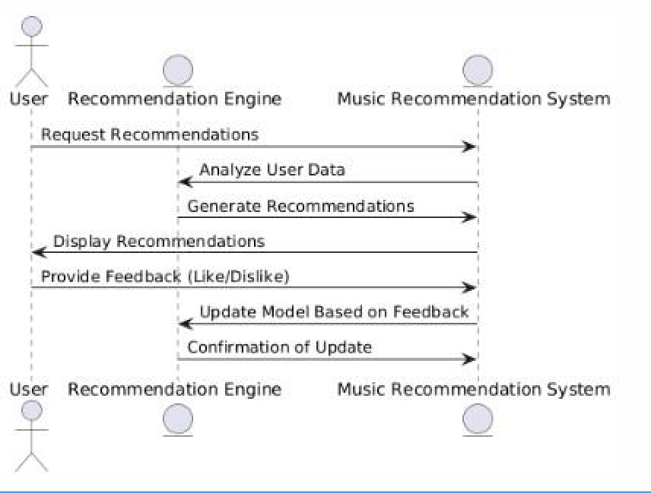

**COMMUNICATION DIAGRAM**

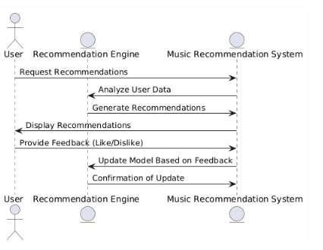

# CLASS DIAGRAM

# 

### Scenario:

### Hassan's Music Recommendation Experience

User Profile:

* **Name**: Hassan Ali Mashwani
* **Preferred Genres**: Pop, Lo-Fi
* **Liked Songs**: None yet
* **Disliked Songs**: None yet

Step 1: Initial Song Recommendations

* Hassan logs into the system, which fetches his preferences (Pop and Lo-Fi genres).
* The system recommends songs that match these genres:
  + **Morning Breeze** (Lo-Fi)
  + **Sunshine Pop** (Pop)
  + **Night Chill** (Lo-Fi)

Step 2: User Feedback

* After listening, Hassan provides feedback:
  + He **likes** "Morning Breeze" (ID: 1).
  + He **dislikes** "Night Chill" (ID: 3).

Step 3: Updated Recommendations

* The system removes "Morning Breeze" (liked) and "Night Chill" (disliked) from the recommendations.
* The updated recommendation list for Hassan:
  + **Sunshine Pop** (Pop)

### Summary:

Hassan’s personalized recommendations are filtered based on his feedback, ensuring that songs he already likes or dislikes are not recommended again. The system becomes more tailored to his preferences with each interaction.

Code:

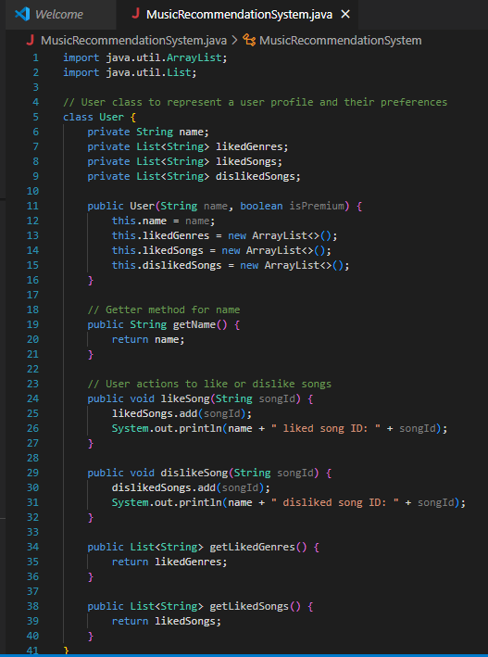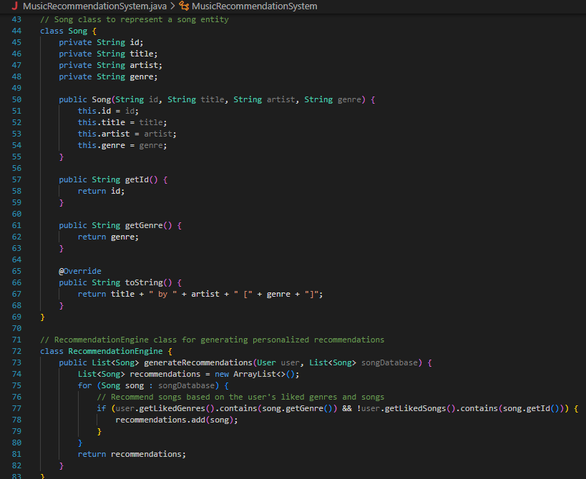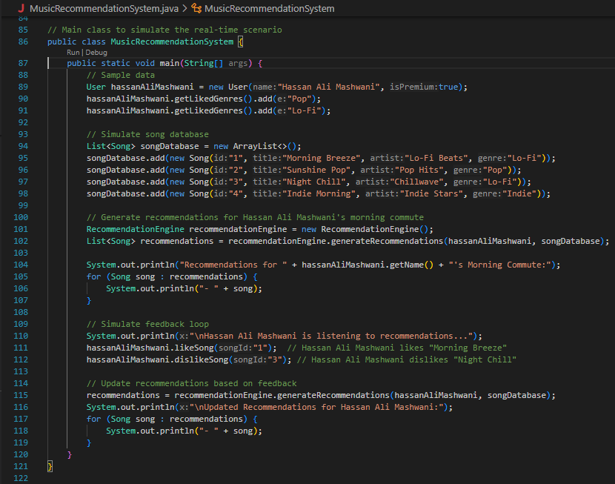

# OUTPUT

